ESE446 Robotics and Dynamics, Assignment: Standford Arm

Rotate theta1 = 0 -> 45 -> 90

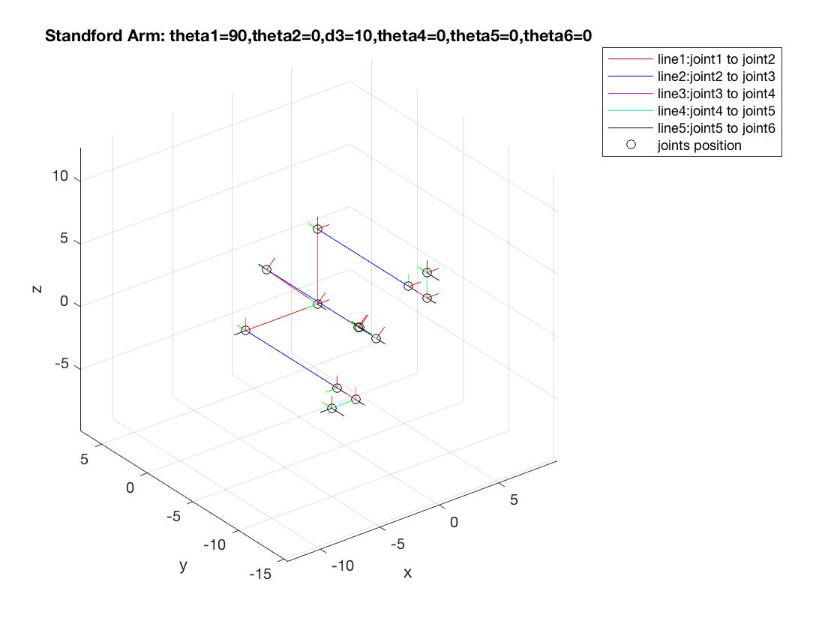

Rotate theta2 = 0 -> 45 -> 90



Rotate theta4 = 0 -> 45 -> 90

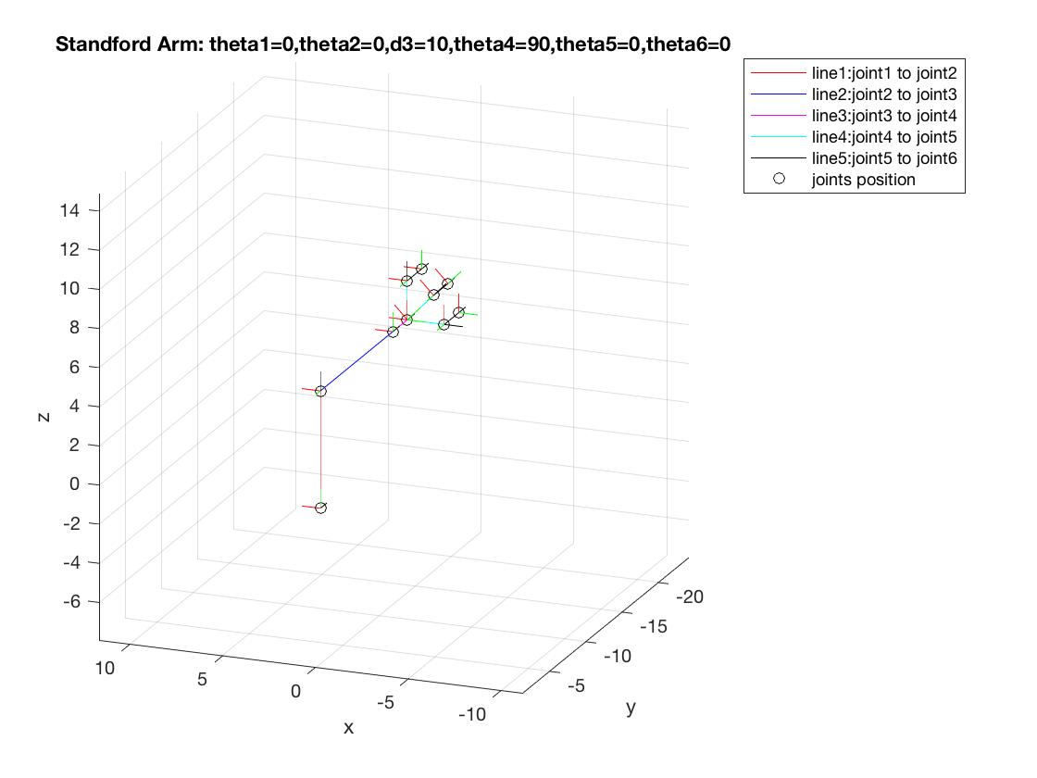

Rotate theta5 = 0 -> 45 -> 90

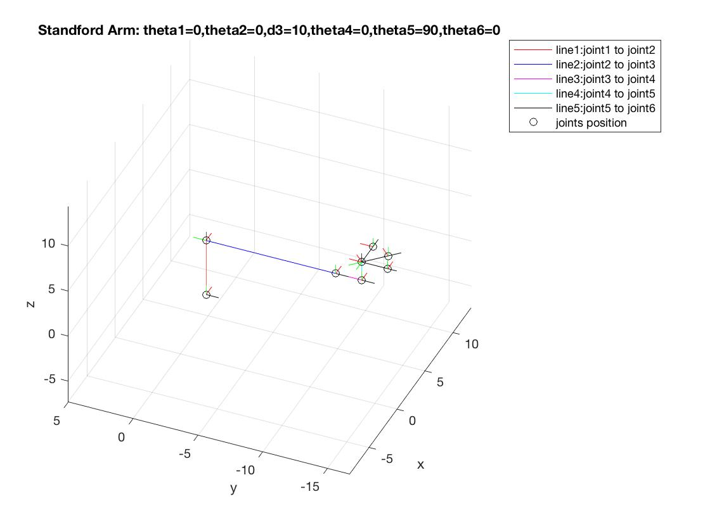

Rotate theta6 = 0 -> 45 -> 90

